BIOS 6611
Biostatistical Methods I

Self-assessment Homework #3

- A cross is made in a genetic experiment in drosophila (a kind of fly) in which it is expected that one-half of the progeny will have white eyes and one-fourth will have a trait called “singed bristles”. Assume that the two gene loci segregate independently. Be sure to show all of your work.
  - What proportion of the progeny should exhibit neither trait?
Possible solution:
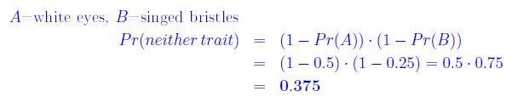
Possible solution:
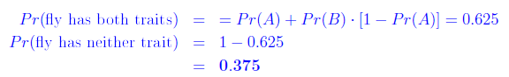

The proportion of progeny that should exhibit neither trait is 0.375.

  - If 5 flies are sampled at random, what is the probability that they will all have white eyes?
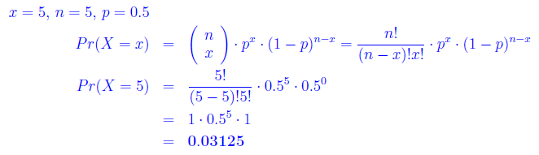
The probability that they will all have white eyes is 0.03125 which means it is unusual for all five flies to have white eyes.

  - What is the probability that none of the 5 flies will have either white eyes or singed bristles?
Possible solution:
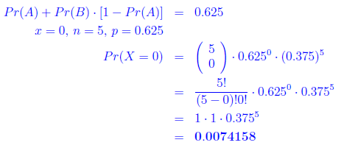

Possible solution:
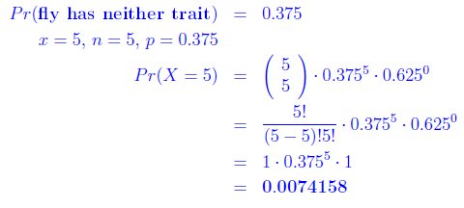
Possible solution :
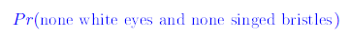
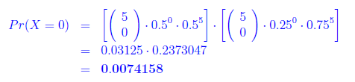
The probability that none of five flies will have white eyes or singed bristles is 0.007416 so it is very unusual for all five flies not to have white eyes or singed bristles.

  - If 3 flies are sampled, what is the probability that at least one of the flies will have white eyes or singed bristles or both?
Possible solution:
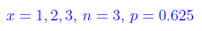
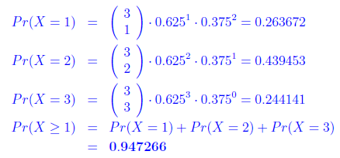
Possible solution:
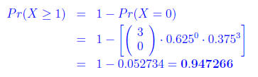

The probability that at least one of the flies will have white eyes or singed bristles or both is 0.947266, so it is not unusual for at least one fly to have white eyes or singed bristles or both.

- This is a gnarly set of probability problems … a favorite … very comprehensive … ☺

Rosner Problems on Infectious Disease:
8th edition: 4.54-4.58
7th edition: 4.58-4.62
6th edition: 4.69-4.73
Be sure to show all of your work.

8th 4.54/ 7th 4.58/ 6th 4.69
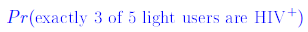
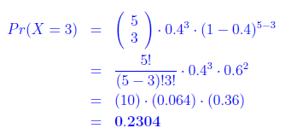
The probability that exactly 3 of 5 users are HIV⁺ is 0.2304 so it is not unusual for 3 of 5 light users to be HIV⁺.

8th 4.55/ 7th 4.59/ 6th 4.70
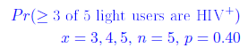
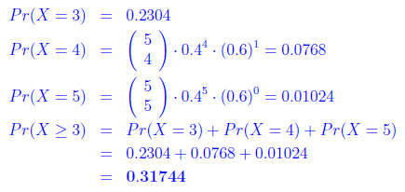
The probability that at least 3 of 5 users are HIV⁺ is 0.31744 so it is not unusual for at least 3 of 5 light users to be HIV⁺.

8th 4.56/ 7th 4.60/ 6th 4.71
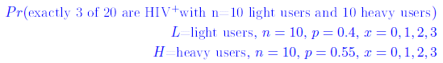
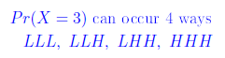

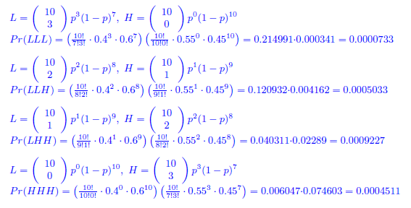
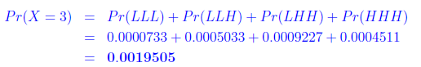

The probability that exactly 3 of 20 users are HIV⁺ is 0.0019505. It is unusual for 3 of 20 heavy and light users to be HIV positive.

8th 4.57/ 7th 4.61/ 6th 4.72
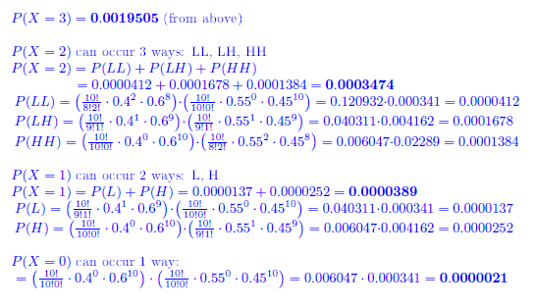

The probability that at least 4 of 20 are HIV⁺ is 0.9977. It is not unusual for at least 4 of 20 users to be HIV⁺.

8th 4.58/ 7th 4.62/ 6th 4.73
Distribution of the number of HIV positive among 20 users is not binomial because p is not the same for both light users (p = 0.4) and heavy users (p = 0.55) so this is a violation one of the assumptions for binomial distribution.

